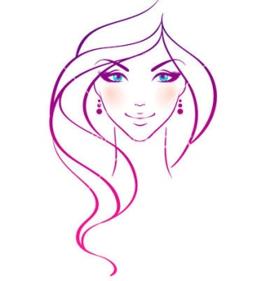 Sarah’s Prices (all prices in pounds)
Hair:
Child’s cut 5.00 to 10.00
Gents cut 5.00 to 10.00
Ladies Wet / dry cut 15.00
Cut and blow dry 20.00
Restyle cut and Blow dry 25.00
Blow dry 10.00 to 15.00
Hair-Up from 15.00
Colours (including cut and blow dry)
Root colour 30.00
Full Head from 35.00
Half Head Highlights from 40.00
Full head Highlights from 50.00
Perms 35.00


